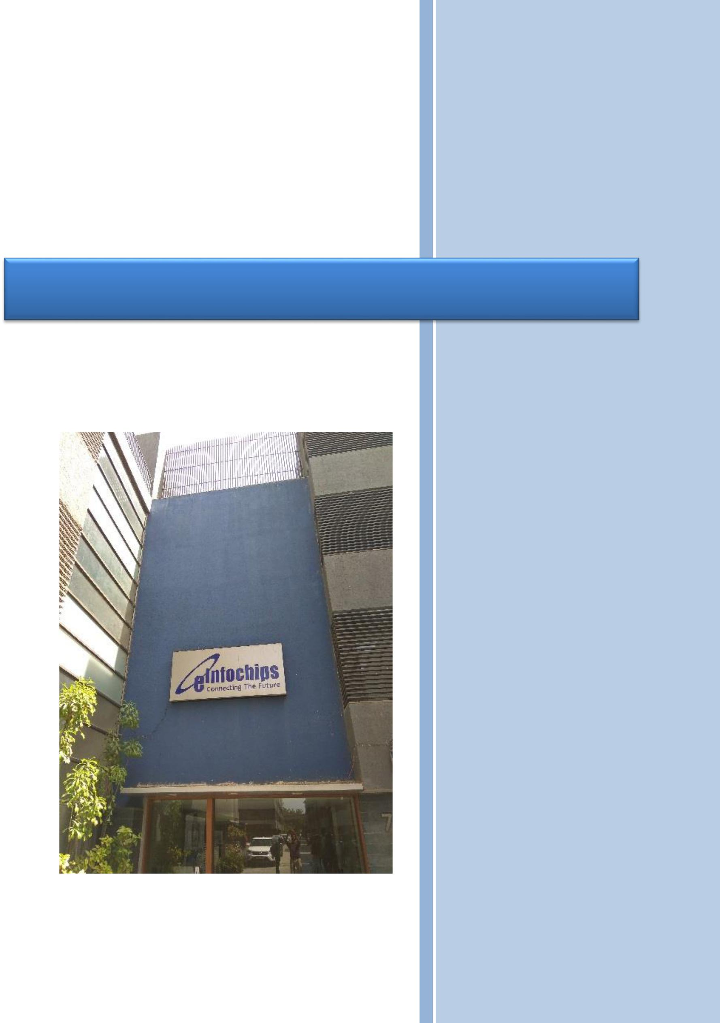

Industrial visit at EINFOCHIPS

Report Compiled by:

Milan Panchal

150280111068

6th Semester,

EC Department,

L. D. College of Engineering.

–

REPORT ON

INDUSTRIAL VISIT AT E-INFOCHIPS

Introduction of Company:

EINFOCHIPS

2, Aryan Park,

Near Thaltej-Shilaj Railway Crossing,

Thaltej, Ahmedabad – 380054.

E INFOCHIPS, It was established in 1998. it’s an Arrow company, is a leading global provider of product engineering and semiconductor design services. With over 500+ products developed and 40M deployments in 140 countries, E INFOCHIPS continues to fuel technological innovations in multiple verticals. The company’s service offerings include digital transformation and connected IOT solutions across various cloud platforms, including AWS and Azure.

About Industrial Visit:

EC Department of L. D. College of Engineering organised industrial visit at EINFOCHIPS on 9th May 2018 especially for semester six students. The main objective behind the visit was to make student aware about how various activities related to are carried out in company. Prof. Arun Nanurbarkar, Prof. Nirali Kotak and Mr. Nilesh along with 62 students have arrived at ENFOCHIPS for visit

As soon as we reached company around 10:00 am and we were guided by Mr. Snehal and an Introduction of company given by him. Then they describe about products of company, Expertise, Client Concept to Substance Services, Semiconductor Journey, ASIC – FPGA Solutions, Design Flow, Front End Design, UFS 2.1 Host Controller IP Verification, Debug & Sign off and Case Study on 3D Graphic SOC Verification. This session ended at 11:30 am.

Then after second session starts at 11:30 am. It was covered by Mr. Balkrishna and Mr. Chintan. They both describe about Physical Design & DFC for Advance ASIC, and give Overview about the various Chip Channel Length variants such as a 7nm, 9nm, 16nm 28nm, Overview about Physical Design in ASIC, Deep Sub-micron Projects at a glance, PD Projects and Solutions and ASIC/SOC/Chip Flow, Manufacture Defects, DFT/ Challenges and Solutions. This session ended at 1:00 pm.

During 1:00 pm to 2:00 pm there was a Lunch Break. Lunch provided by EINFOCHIPS Canteen. There was an Aloo Mutter and Bhindi’s Sabji, Roti, Buttermilk, Jalebi, Papad & Rice in a lunch.

After lunch we were go for an Experience Zone – Product room. The tour comprised of collection of different projects, including Avionics, Video Management System, Health Care, Home Automation, IOT based Systems, Transport System, Automotive, ASIC and Communication Standards. This session ended around 3:00 pm.

Then after the last session was Q&A session. In this session students interact with company’s engineers about different VLSI based topics. All students learn different things with a great expertise. And at the end of the day we all taking a group photo along with our professors Mr. Balkrishna and Mr. Chintan.

We all Thankful to Prof. Usha Neelkanthan and to arrange this great and valueable industrial visit. We also thankful to Prof. Arun Nandurbarkar, Prof. Nirali Kotak and Mr. Nilesh for this industrial visit.

Glimpses of EINFOCHIP Industrial Visit:
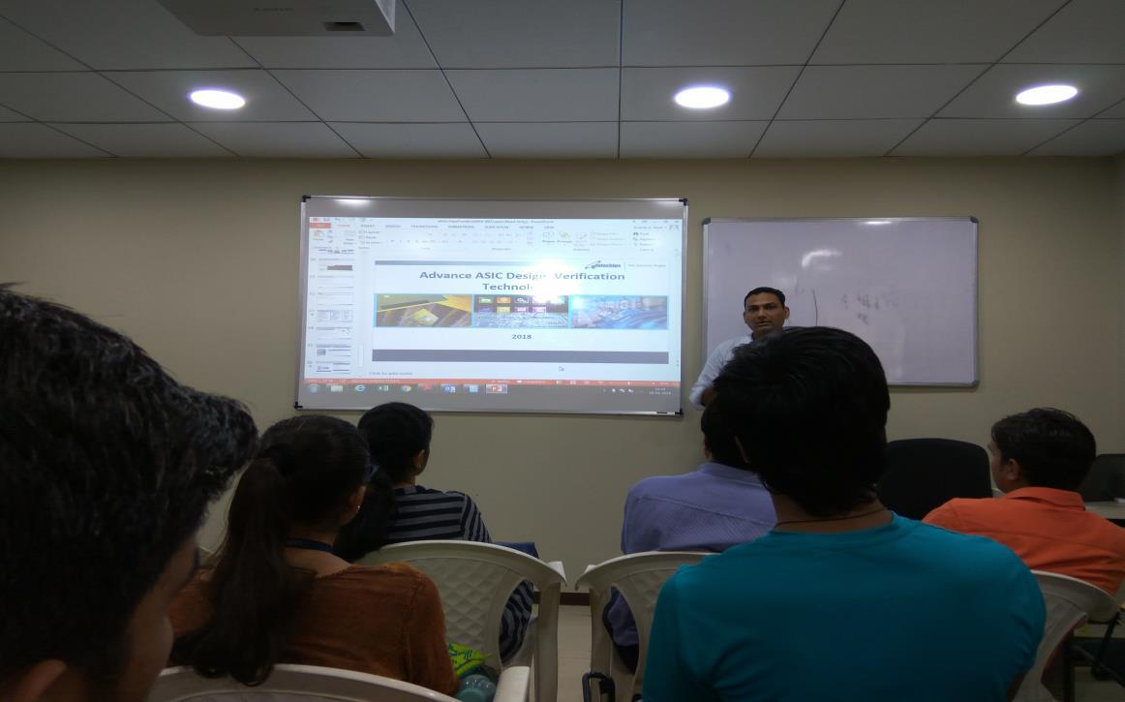

Photograph 1: First session, covered by Mr. Snehal.
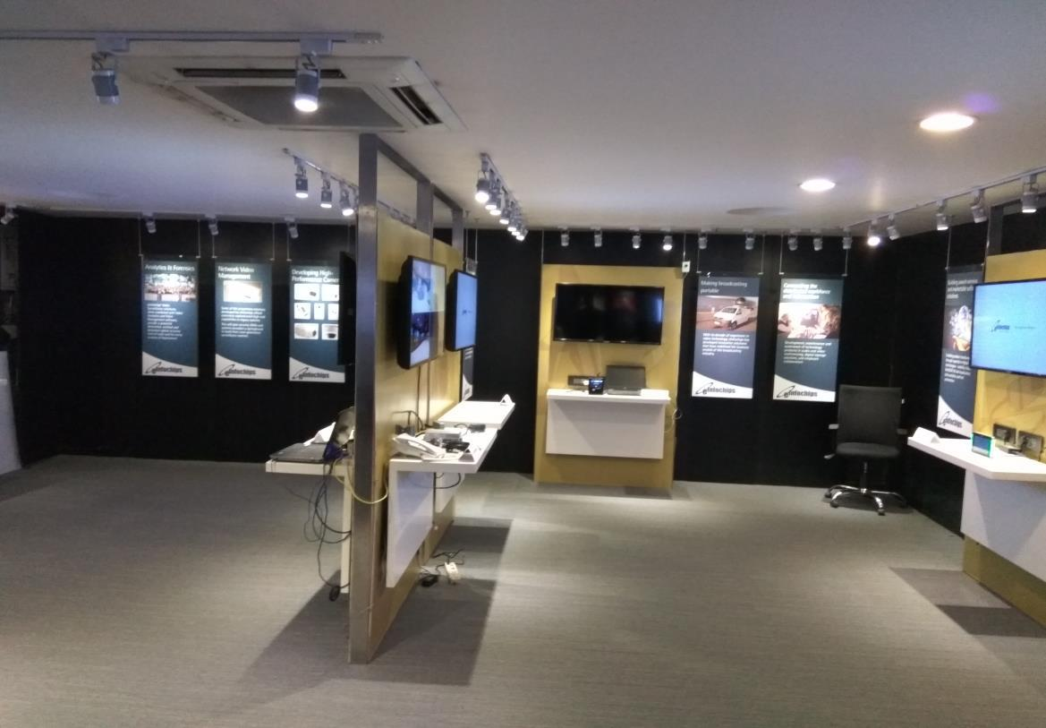

Photograph 2: Experience Zone – Product room

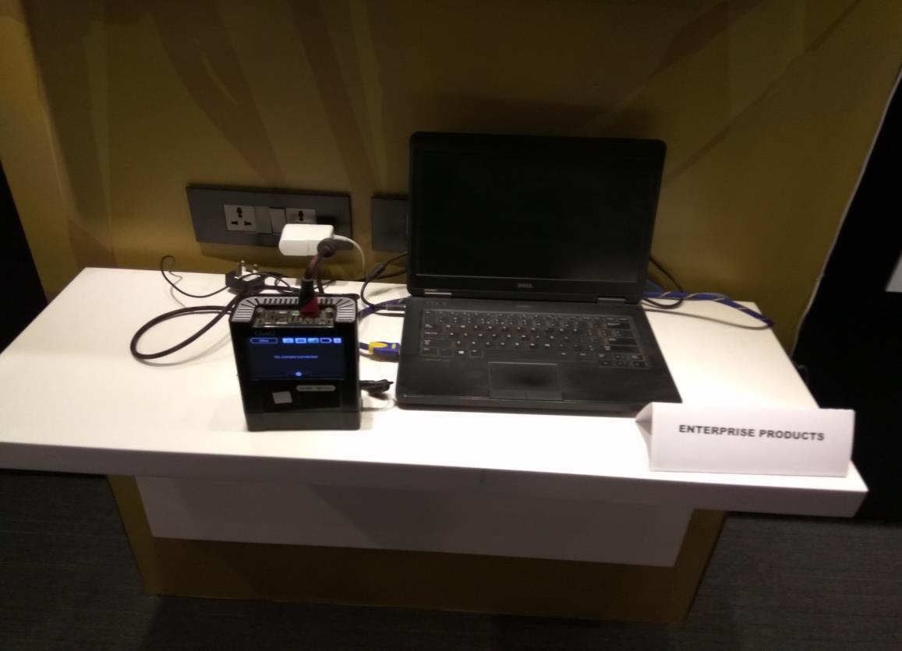

Photograph 3: Experience Zone – Product room
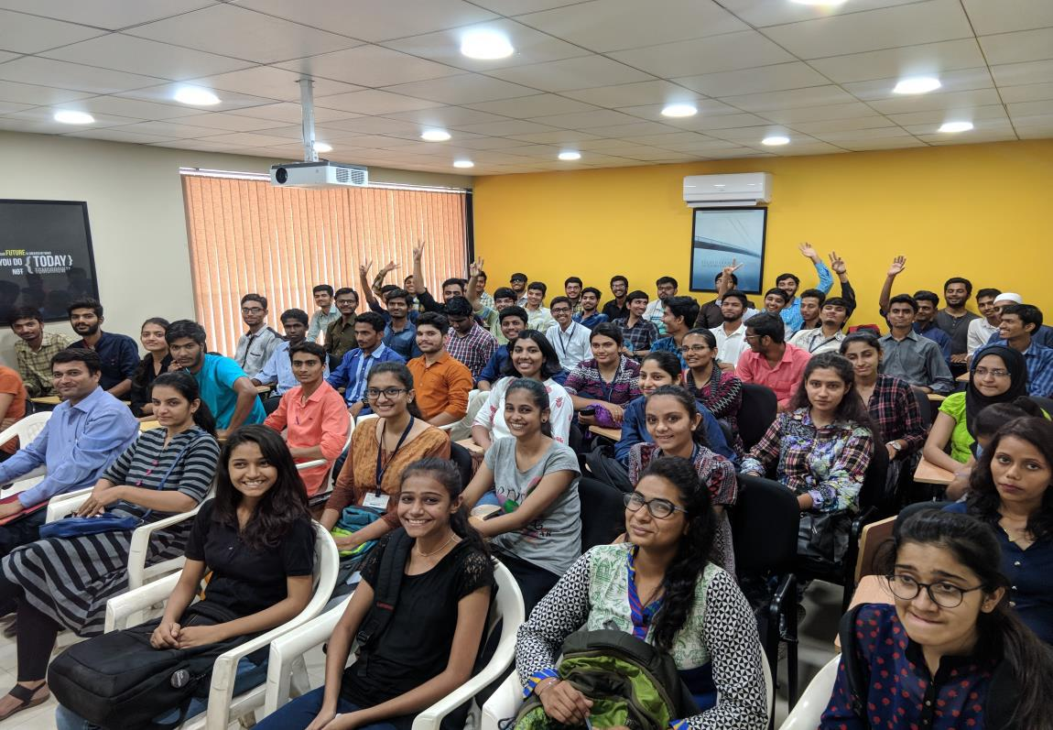

Photograph 4: Group Photo at Tutorial Room

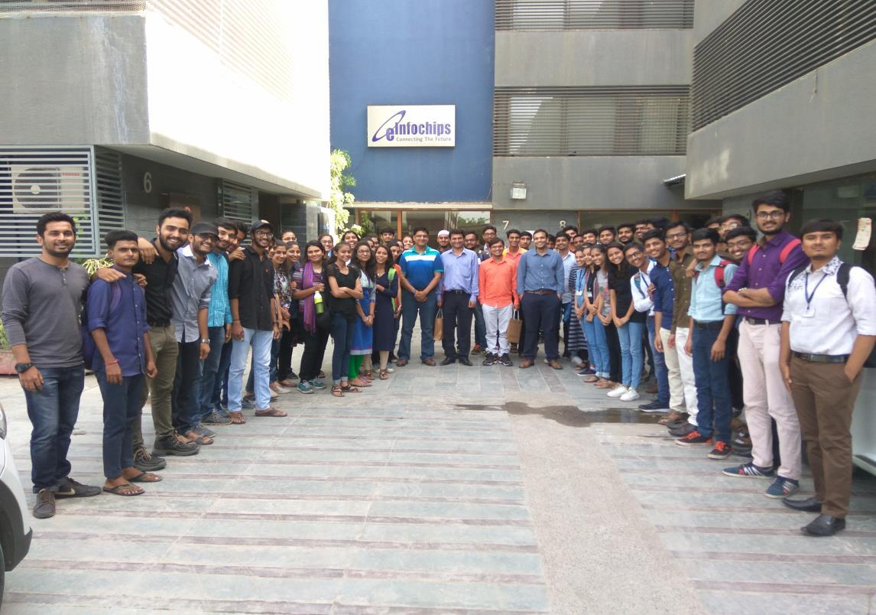

Photograph 5: Group Photo with LDCE Professors, Mr. Balkrishna and Mr. Chintan

