A Brief Report of Tech-Talks under Banner of SAEINDIA-GUJARAT DIVISION (W/S).

About The Program

L.D College of Engineering, Ahmedabad & SAE INDIA-GUJARAT DIVISION-(W/S) had organized awareness program on Introduction to ISO 26262 & Future Scope of CNG as Transportation fuel at L D college of Engineering with support of S-B Solutions & Neet-Vasant Pvt.ltd on 06/07/2019 from 11:00 a.m. to 4:00 p.m.

Prof.R.J Jani along with Prof.Mazar Shaikh & Prof.Jayendra Vasani welcomed and introduced the first Session Speaker Mr.Nandip Gohel (System safety Engineer at General Motors in Michigan, U.S.A.)

1. ISO 26262

Mr.Nandip gave introduction about ISO 26262. He explained the Students that what is the ISO 26262 & why is very important in today’s advance technological world. Then he explained the functional safety in Automotive Domain and give broad explanation on it. He also introduced the students about benefits of implementation of functional safety from OEM's perspective. Further he discussed with students that how the functional safety implemented in the vehicles? After, he gave some examples of how the functional safety would be implemented on Active aero system. He also discussed some functional failures of the top brand vehicles which leaded to the very big accidents in past due to lack of the functional safety standards.

Session was concluded with Q/A Session. Prof. R.J Jani again thanked the speaker & gave momento on behalf of L.D.College of the Engineering.

2. Future Scope of CNG as Transportation fuel.

After the Lunch Break, Prof.Mazar Shaikh welcomed and Introduced Second Session Speaker Mr.Darshan Soni (Owner Neet-Vasant Pvt.ltd,Ahmedabad) among the students.

Mr.Darshan Soni gave his company's introduction and shared its objectives. He shared data about the pollution and crude oil consumption in India verified by the central government of India. He also shared the data of United Nations which is seriously a big issue on the Pollution. He gave information to students that how we are destroying our climate by our own hands.

After this, he suggested some steps to secure our future from these hazardous things. He explained briefly the future scope of the renewable energy as the transportation fuel and industrial fuel also. He introduced the students about the natural gases like, CNG, L-CNG and Bio-gas. In further, he said that Gujarat and other states of our country has big source of the natural gases. He also shared the benefits of CNG and other natural gases as a transportation fuel.

In the end, Prof.R.J Jani thanked the all students and advised them to do some engineering projects in the renewable energy field to decrease our nation's dependence on the gulf countries. He also thanked Mr.Darshan Soni and honored him by momento on behalf L.D.College of Engineering.

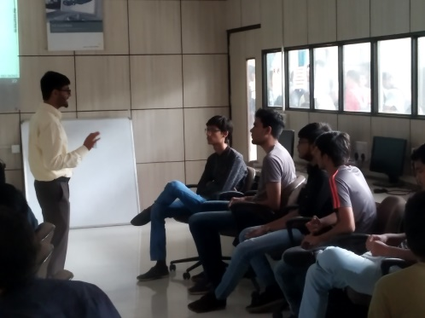
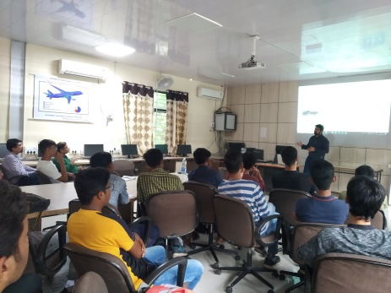
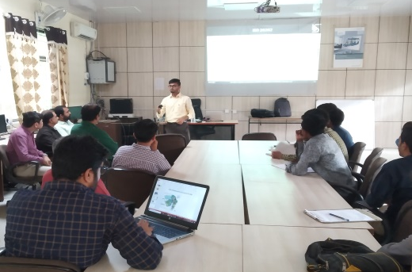
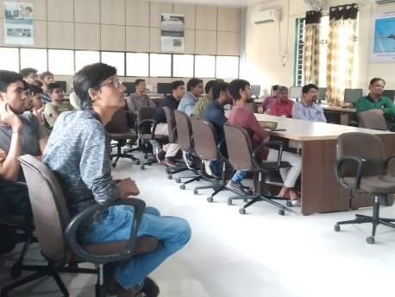
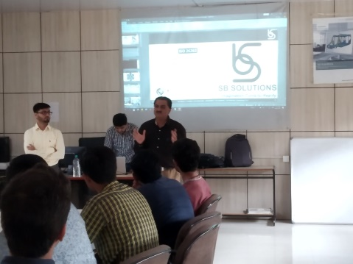
Glimpse of this Tech-talks.
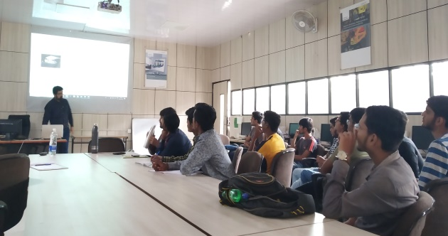
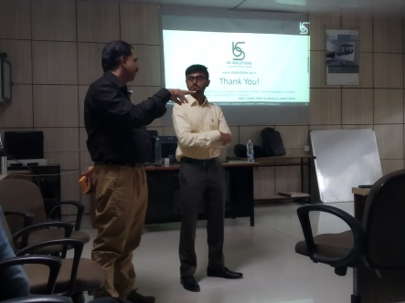
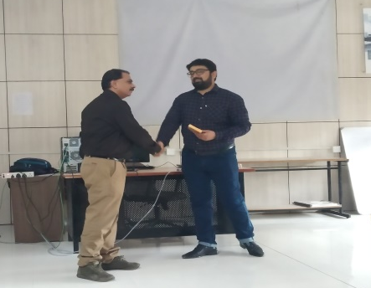
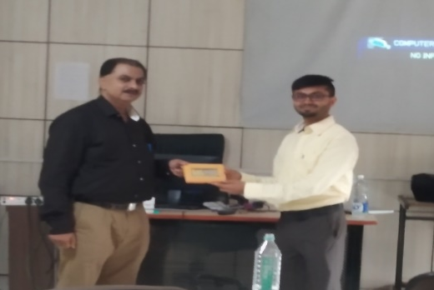
Thank You.

