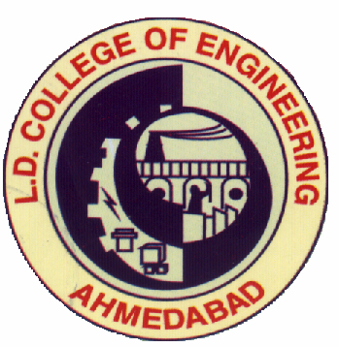
ISTE APPROVED

SHORT TERM TRAINING PROGRAMME ON

Advanced Manufacturing Techniques
using NX CAM

07/11/2016 to 11/11/2016

Chief Patron
Dr. G. P. Vadodaria

Convener
Dr. G. H. Upadhyay

CoE-Siemens Coordinators
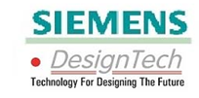
Prof. Y. D. Vora, Prof. B. C. Khatri

Program Coordinators
Dr. K. G. Dave, Prof. S. A. Saraswat

Co-Coordinators
Prof. S. P. Shah, Prof. D. J. Parmar
Prof. D. U. Panchal, Prof. A. C. Pambhar

Organized by
Mechanical Engineering Department
Automobile Engineering Department
L. D. College of Engineering, Ahmedabad

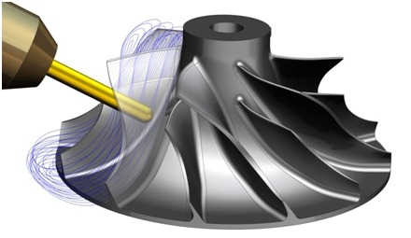

- It is a pleasure to repot that Mechanical Engineering Department and Automobile Engineering Department have completed four Sort Term Training Program approved by ISTE and CTE during diwali vacation to update the knowledge and practical skills of faculties of degree and diploma engineering colleges as well as to fulfill their career advancement requirement. One of them was on “Advanced Manufacturing Techniques using NX CAM during” during 7th to 11th November 2016 at Siemens Centre of Excellence, Mechanical Engineering Deparment, L.D.College of Engineering, Ahmedabad. Principal Prof.(Dr.) G.P.Vadodaria and Shri Nishith Bhatt, General Manager of Design Tech, inaugurated the function on 7th November. Prof. G.P.Vadodaria emphasized to improve the quality of engineering education by continuous learning. Mr. Nishith Bhatt gave the information about advance softwares in manufacturing and design area. Prof.(Dr.)K.G.Dave gave the vote of thanks. The program ended with high tea.
- Fifteen faculties from different Engineering colleges participated in this STTP. They found the programme very useful from the theory and practical aspects. During these five days the various topics covered were Sketching with NX9.0, Modeling with NX9.0, Creating the manufacturing setup for Milling, Different Pattern cutting, Groove milling with T-slot cutter, Floor and wall Milling, Drilling and Text Milling, Tool path information output, Creating the manufacturing setup for Turning, Facing, Drilling, Rough and finish ID and OD. CoE laboratories including Flexible Manufacturing systems, Rapid Prototype Machines-Fused Deposition modeling, Mechatronics lab, MTAB Lab, MCMT Lab, SITRAIN Automation I, SITRAIN Auotomation II, SITRAIN Mechatronics, SITRAIN Electrical and two computer Labs were visited by participants under the guidance of well trained CoE faculties.
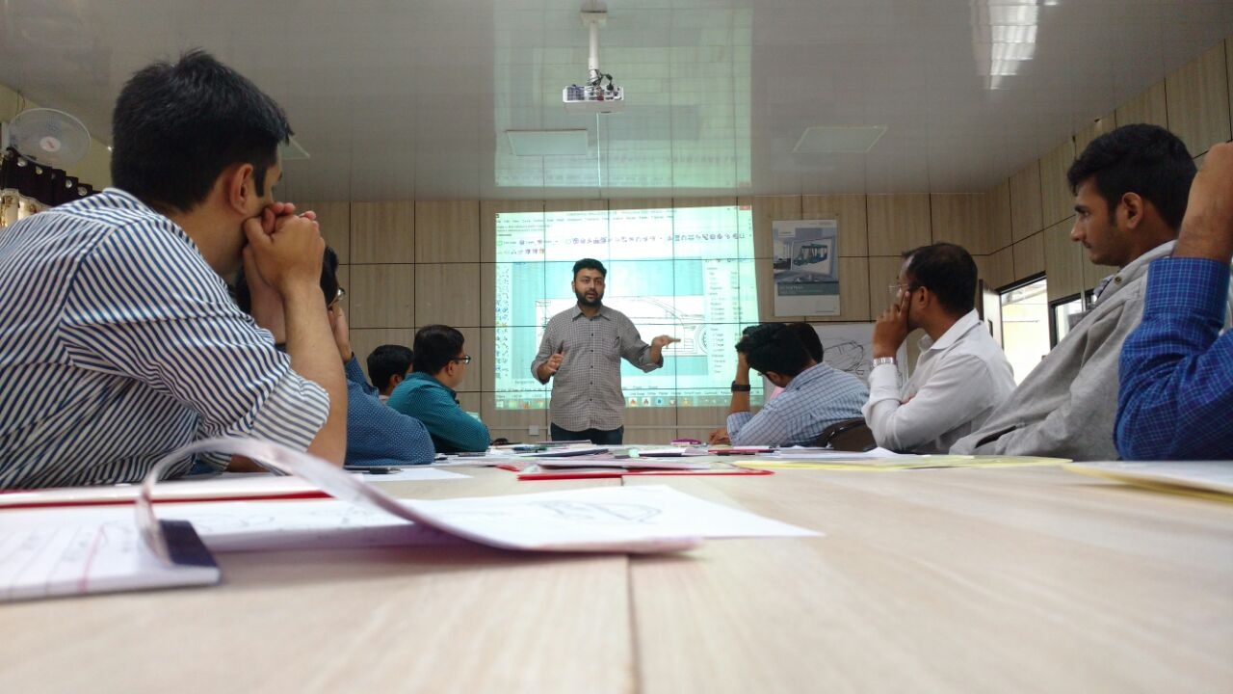

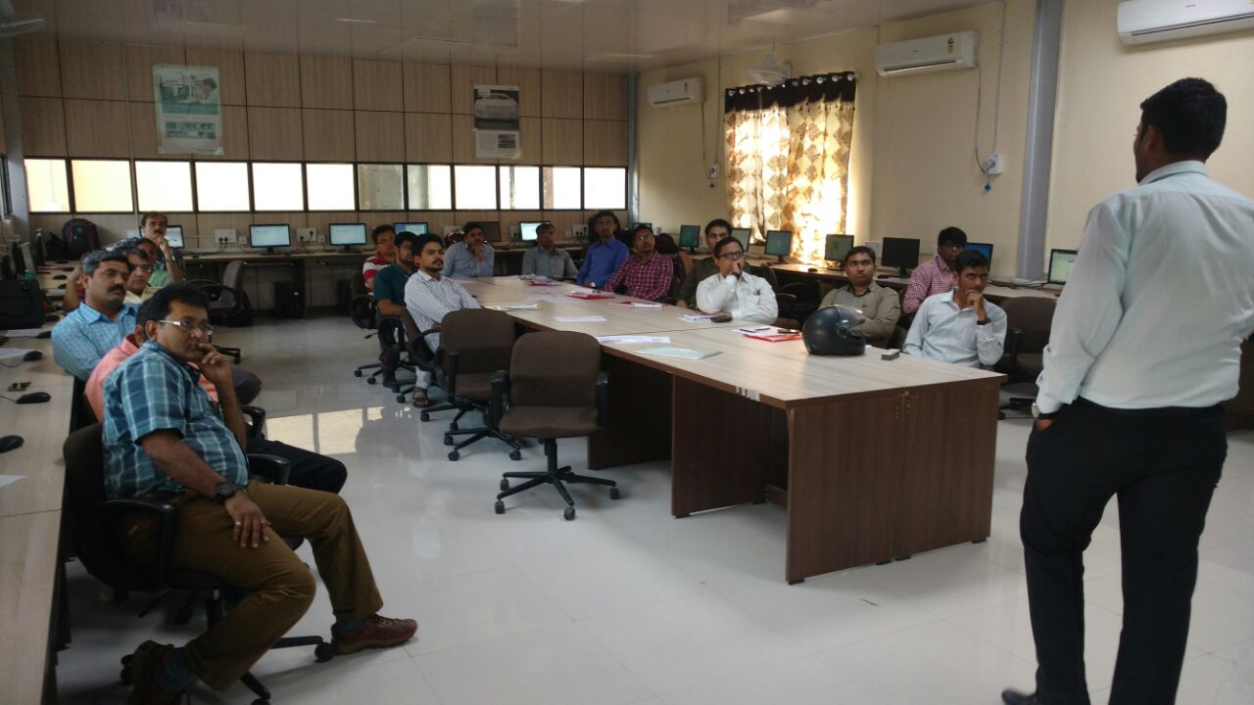

- On 11th November during valedictory function, Mr. Jignesh Patel from Khodiyar CAD Centre has appreciated the program and conveyed his thanks to Principal, Head of the department and Coordinators for arranging the training on such advance areas. Certificate of participation in STTP has distributed to all participants. Prof. S.A.Saraswat gave the vote of thanks. Participants gave their valuable feedback about nice conduct of course content, overall management, punctuality in time schedule and quality of breakfast and lunch.

