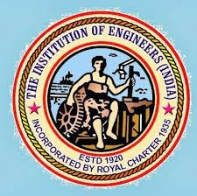
REPORT ON THE WORKSHOP TITLED “REAL TIME APPLICATIONS OF ARDUINO”

Speakers:- Abhay Gosai (President of IEI(EED) Student Chapter)
Shwetal Shyara (Vice President of IEI(EED) Student Chapter)
Om Bhatt (Social Media Handler of IEI(EED) Student Chapter)
Date:- 5th May 2023
Time:- 2:45 PM to 5:00 PM
Venue:- Chanakya Hall, Wing-3, Electrical Engineering Department, L.D.C.E. Ahmedabad.
Patron:- Prof. (Dr.) R.K. Gajjar, Principal, L.D.C.E
Mentor:- Prof. (Dr.) K.P. Badgujar, H.O.D., EED, L.D.C.E.
Coordinators:- Prof. (Dr.) Kunal A. Bhatt
Prof. Mihir Vasavda

The workshop on “Real time applications of Arduino” began with offering prayer. Thereafter, welcome speech was addressed by Prof. (Dr.) J. R. Iyer,. In addition, the importance of this training and significance to learn Arduino was discussed by Prof. F.A. Macwan and Prof. H.N. Raval

The speakers for the workshop were, Abhay Gosai, Shwetal Shyara, Om Bhatt, students of semester-6, EED, LDCE. Initially, arduino architecture including pin-diagram was discussed by speakers. Moreover, they also discussed the brief about the sensor they were going to demonstrate such as relay switch module, IR sensor module, tilt switch module, and Ultra Sonic sensor module.
The students were divided into three groups for practical session of the workshop. In practical session students were provided exposure to understand the code first and thereafter, students were allowed to performed on their own.

Speaker Shwetal Shyara explaining about Ultrasonic Sensor and its working principle. Speaker Abhay Gosai explained coding of relay module and working of module.
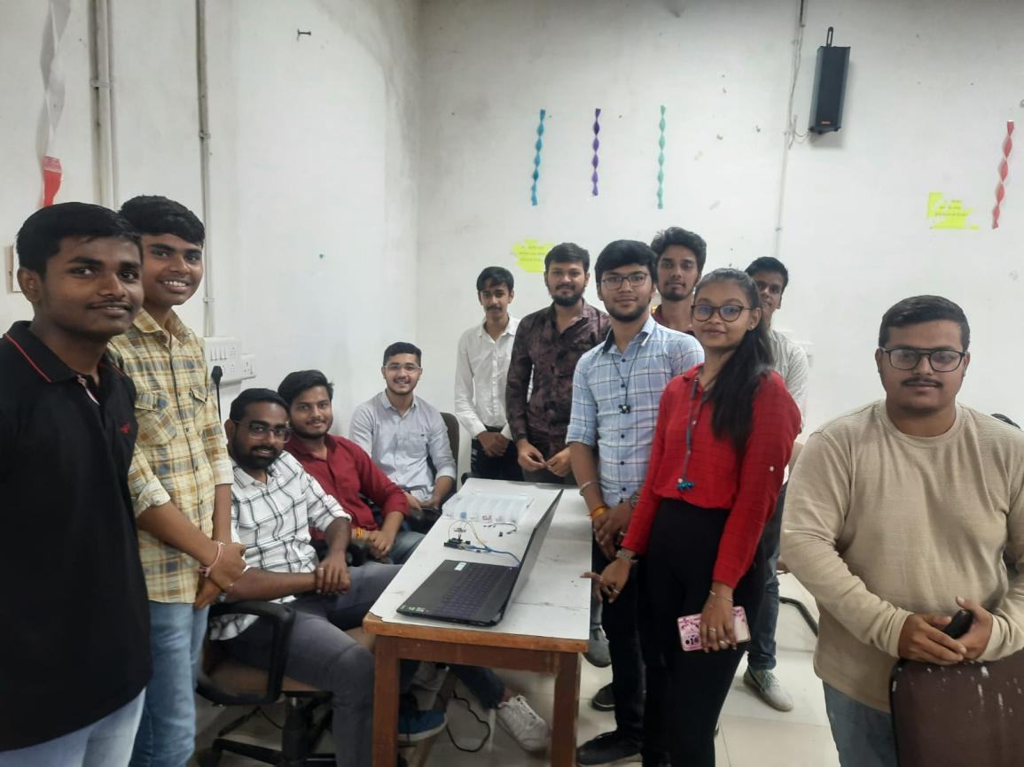
At the last, head of the department, EED, Prof. (Dr.) K.P. Badgujar delivered vote of thanks and framed new core team for IEI students’ chapter.
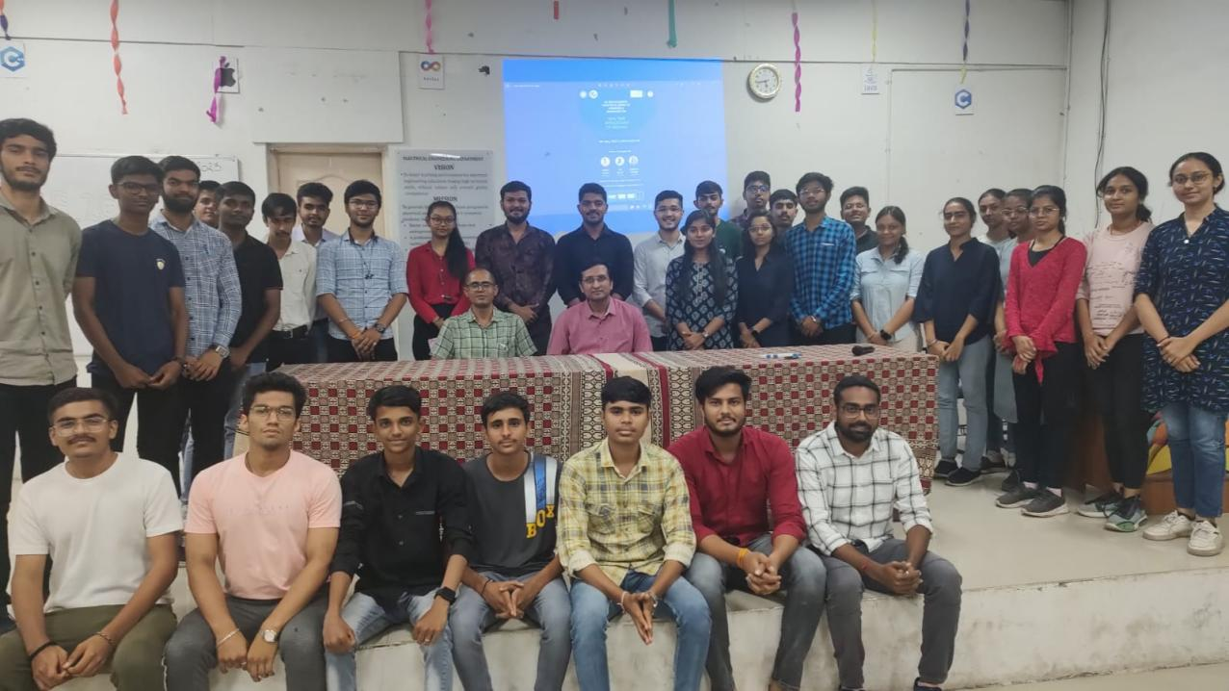

Feedback Analysis

