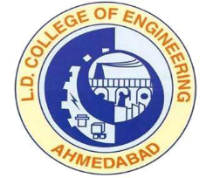 | L.D.College of Engineering,Ahmedabad-380015  एल.डी.कोलेज ऑफ़ इंजीनियरिंग, अहमदाबाद–३८००१५  લા.દ.ઈજનેરી મહાવિદ્યાલય,અમદાવાદ-૩૮૦૦૧૫  Phone:079-26306752 (Office), 26303190  Email: ldce-abad-dte@gujarat.gov.inWebsite: www.ldce.ac.in
L.D.C.E./STS/2022/ Date: - / /2022
COURSE COMPLETION CERTIFICATE
(NO BACKLOG CERTIFICATE)
TO WHOMSOEVER IT MAY CONCERN
Sr.No. | Semester | CGPA | Grade
1 | Semester -I
2 | Semester -II
3 | Semester-III
4 | Semester-IV
5 | Semester-V
6 | Semester-VI
7 | Semester-VII
8 | Semester-VIII
This is certify that Mr. ………………………….was a bonafide student of our college for the Academic period …………… TO …………….(4 years)successfully completing Bachelor of Engineering(…………………………………)from this College. He/She successfully completed F.Y.BE, SYBE, TYBE, Fourth Year BE Examination with the following grades without any Backlogs

Principal
L.D. College of Engineering
Ahmedabad

