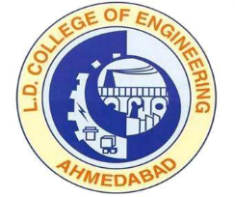 | L.D.College of Engineering,Ahmedabad-380015  एल.डी.कोलेज ऑफ़ इंजीनियरिंग, अहमदाबाद–३८००१५  લા.દ.ઈજનેરી મહાવિદ્યાલય,અમદાવાદ-૩૮૦૦૧૫  Phone:079-26306752 (Office), 26303190  Email: ldce-abad-dte@gujarat.gov.in Website: www.ldce.ac.in
L.D.C.E./STS/ / Date: / /
BONAFIDE CERTIFICATE
This is to certify that Mr. /Ms………………………………………………..
His Enrollment No. ……………………................................ is a bonafide student of this Institute studying in BE/ME/PDDC/MCA Sem. …………
Branch ……………………….. During the year ………………
And other details related to him are as below:
ENROLLMENT NO. | …………………………………. | PHOTOGRAPH
ROLL NO.
PRESENT ADDRESS
PERMANENT ADDRESS |  | SIGNATURE
CONTACT NO.

PRINCIPAL
L.D.COLLEGE OF ENGINEERING
AHMEDABAD

