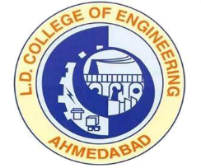 | L.D.College of Engineering,Ahmedabad-380015  एल.डी.कोलेज ऑफ़ इंजीनियरिंग, अहमदाबाद–३८००१५  લા.દ.ઈજનેરી મહાવિદ્યાલય,અમદાવાદ-૩૮૦૦૧૫  Phone:079-26306752 (Office), 26303190  Email: ldce-abad-dte@gujarat.gov.inWebsite: www.ldce.ac.in
L.D.C.E./STS/ / …. /……/……
Cancellation Certificate
This is to certify that Mr. ………………………………….was studying in this institute in B.E. …………………. Engineering in ……… Semester. His Enrollment No. is …………….. He has applied for cancellation of his admission; institute has no objection for his cancellation of admission.

Principal
L.D. College of Engineering
Ahmadabad

