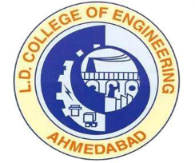 | L.D.College of Engineering,Ahmedabad-380015  एल.डी.कोलेज ऑफ़ इंजीनियरिंग, अहमदाबाद–३८००१५  લા.દ.ઈજનેરી મહાવિદ્યાલય,અમદાવાદ-૩૮૦૦૧૫  Phone:079-26306752 (Office), 26303190  Email: ldce-abad-dte@gujarat.gov.inWebsite: www.ldce.ac.in
L.D.C.E./STS/ / Date: - 01/01/2020
Character Certificate
This is to certify that Mr. /Ms……………………………………………….. was student of this college from ………. to ………. in B.E./M.E./MCA/PDDC in ………………….. Engineering. His/Her Enrollment No. is ……………….. He /She has completed his/her study in ……………... in Regular course with CGPA ……………….
The course is approved by ALL INDIA COUNCIL FOR TECHNICAL EDUCATION, NEW DELHI AND our college is affiliated to the Gujarat Technological University, Chandkheda. The medium of instruction and examination was in English.
He / She bears good moral character according to best of my knowledge.

Principal
L.D. College of Engineering
Ahmedabad

