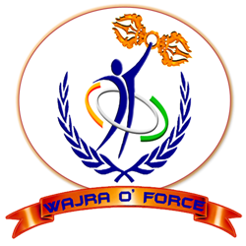
  - halla bol II

22TH AUGUST 2016

Women Safety

L. D. college of Engineering

Organized by Woman Development Cell

Sponsored by RUSA

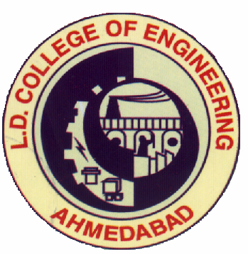

It is pleasure to repot that as per Ref: Letter CTE/AK/Halla Bol/K(2)/2016/21409, Dated 20/8/2016. L. D. College of Engineering have successfully completed ‘Halla Bol’ program under Women Development Cell, LDCE supported by RUSHA on 22nd August 2016 at ‘Araybhatt Hall’ LDCE. The event is for awareness of woman safety and woman empowerment. This is delivered through BISAG channel No. 1 during 12 to 1.30.
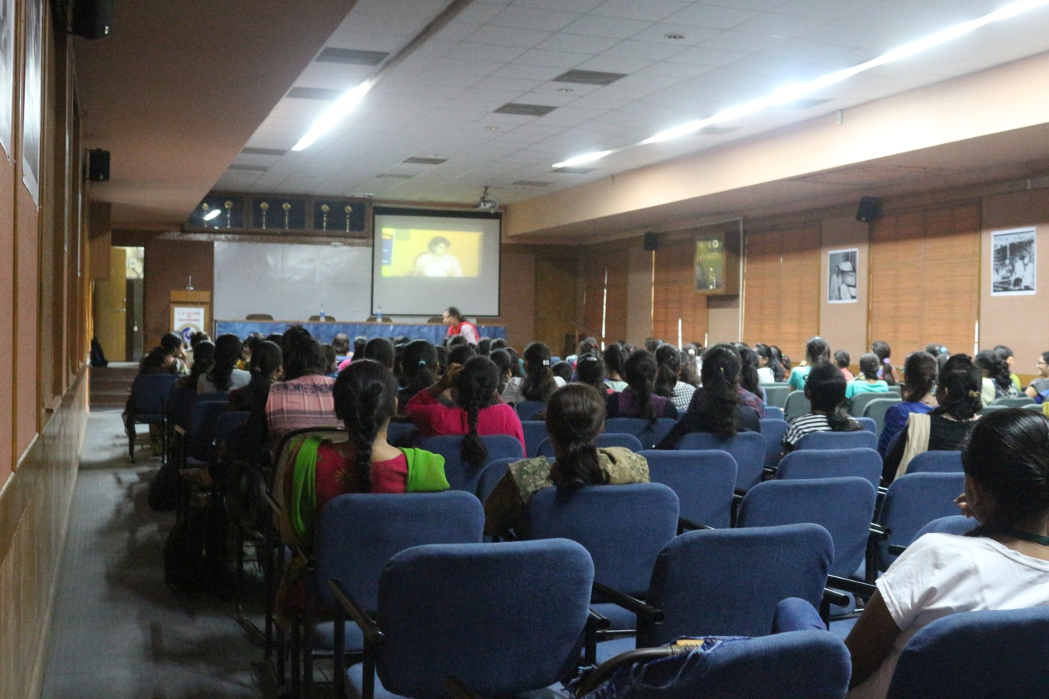

There is 75 participates from female faculties and girl students of LDCE. Prof. (Dr.) K.G.Dave, Mechanical Engineering, Convener, Women Development Cell, LDCE and Prof. P J Brambhatt, EC Dept., Member of WDC, LDCE have successfully co-ordinate the program. Online quotation–answer section with Ms. Ruzan Khambhata madam is very helpful to understand the details of Helpline 1091 service. She has also gave very important massage to audience through bisec service for women self defense in some specific condition when woman with small baby and some different situations like handicap or pregnant. The program was ended by refreshments to all participants.
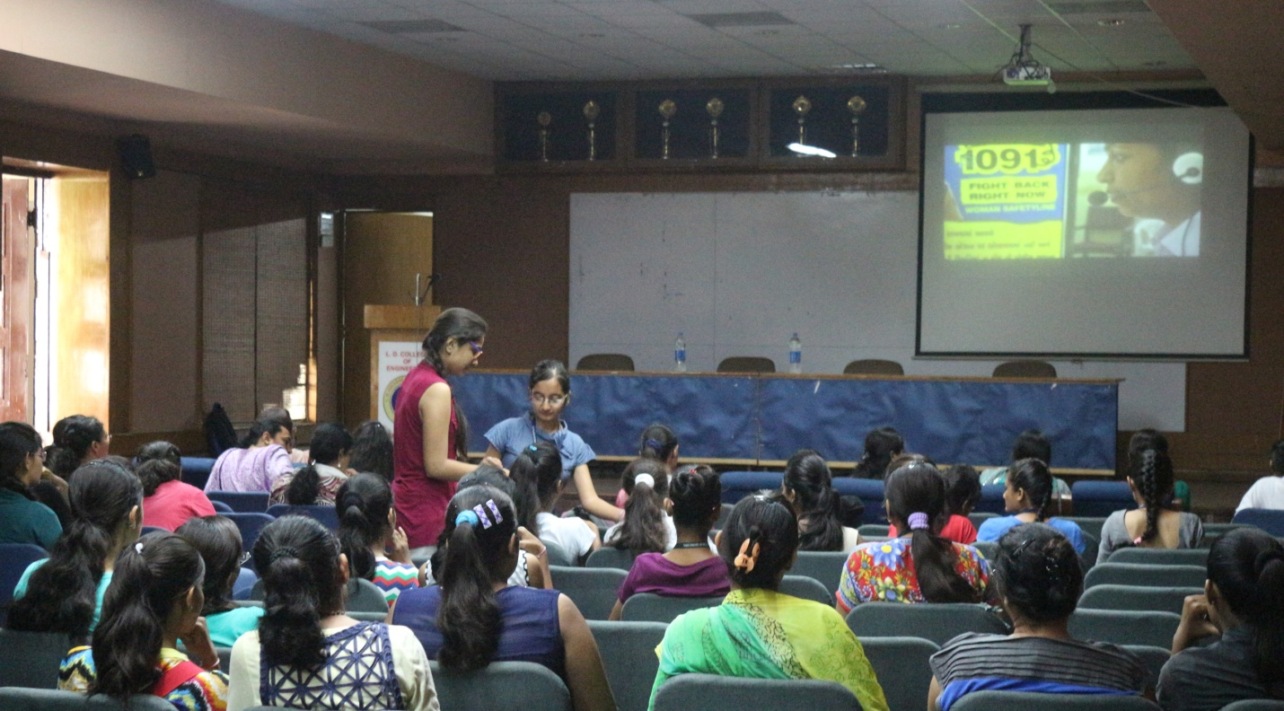

With help of convener of RUSA Prof. N. K. Shina and member of WDC Prof. P.I. Modi, Prof. Z.B. Parekh, Miss Tejal Brevadiya and enthusiasm members of Healthy Campus Raj and Yamuna, this event became informative and successful.

