Automobile Engineering Department

4. STUDENTS’ ACTIVITIES

Automobile Engineering Department

- A world in motion training was held at L.D.COLLEGE OF ENGINEERING ON 24th September 2019. AWIM joint Convener MR. KARTIKEYA PATEL gave training to the volunteers. Twenty Five volunteers were present in training session.
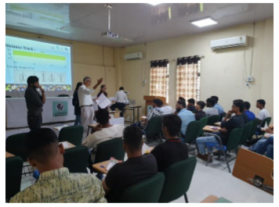

- Kishan Gohel (Vice president-SAE Club) volunteered final event of AWIM at Swarnim Startup and Innovation University on 24th October 2019. The event was in association with SAE India Western Section.
- 9 students of Automobile Engineering Department successfully completed Internship at TATA Motors, Sanand plant.

5. DEPARTMENTAL ACTIVITIES

- 30 Students and Faculties of Automobile Department had visited Automotive Research Association Institute, Pune on 12th October 2019.


