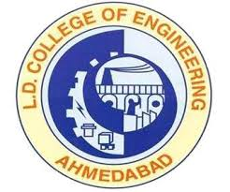

REPORT ON
“ADANI (MUNDRA PORT) VISIT”
Mechanical & Automobile Department
(5th Sem-2015)
GROUP-1 ( 4/10/2015 to 5/10/2015) (79 students)
GROUP-2 ( 5/10/2015 to 6/10/2015)(81 students)
 | FACULTY COORDINATOR
 | Prof. P.K.Brahmbhatt
 | Prof. M.M.Makwana
 | Prof. H.A.Shukla
STUDENT COORDINATOR
Dhaval Prajapati | Prof. H.P.Patel
Falgun Patel | Prof. J.G.Parmar
Bhavin Patel | Prof. R.J.Chobe
Vraj Patel | Prof. S.B.Shah
 | Prof.P.R.Parekh

Our visit had started in early morning at 5 o’clock. We left the college campus and reached to Mundra-Kutch at 1 o’clock in noon. After getting freshed and having lunch we went to visit ADANI WILMAR REFINERY. That was good place. There were Packing department, Refinery department, Cold storage, etc. We saw whole process of packing of refined oil packing in bottles and pouch. From there we are taken to visit the Adani Port, there were huge cargo ships, Container ships, oil container ships. Those all ships were being loaded and un-loaded. It was very large place to walk so we saw all these thing from inside the bus. After visiting the port we came back to our rooms and had tea-coffee. After that we saw the presentation of Adani Port Thermal Power Plant. That was a brief introduction of Adani power Plant. Adani is Asia’s no.1 thermal power station which has capacity of 4620 MW power generation. In evening we went to very beautiful and peaceful temple of Lord Shiva. After having dinner we spent some time for fun with friends and Professors also.
Now on the second day morning we got ready at 6o’clock and got together in a hall for Yoga and Laughing exercise. It was wonderful feeling for all. We enjoyed allot. We visited west port. There were 25 births and jetty. Well managed structure for operating the whole port. There are four processes in the port which are – Anchoring of ship – Birthing – Loading – Unloading – Custom Checking. After visiting the port we took visit of Adani Thermal Power Plant. The plant has nine power generating units. It is world's largest single location coal-based thermal power plant. Among nine unit 5 to 9 units involves super- critical boiler technology. Each boiler is imported from china. And these Super critical boiler have capacity of 660MW.Control rooms were there to control the power generation system. Adani power was started as a power trading company 1996. It started generation in July 2009 by implementation of its first 330 MW of 4620 MW at Mundra. The Mundra super mega project is the largest coal-based power project of India and fifth largest in the world. The company commissioned another three 330 MW by November 2010 and country's first supercritical unit of 660 MW on 22 December 2010, making its capacity 1980 MW. 0n 6 June 2011 it synchronised its second unit of 660 MW bringing the total generating capacity to 2640 MW and on 2 October 2011, it synchronised its third super critical unit with national grid. With this, Adani power has become largest thermal power generating company in the private sector, and the Mundra plant has become India's Largest Power plant with capacity 3300 MW. In February 2012, it commissioned the last unit of Mundra Project to take its capacity to 4620 MW which makes the Mundra TPP to be the largest privately held thermal power plant in the world and fifth largest on an overall basis. After visiting the plant we came back to our rooms. After having lunch we left Mundra at 2 o’clock and back to Ahmedabad at night.
Really it was very useful and knowledgeable visit for us as Mechanical Engineers. This type of visit should be conducted every year for better future of our students.

- 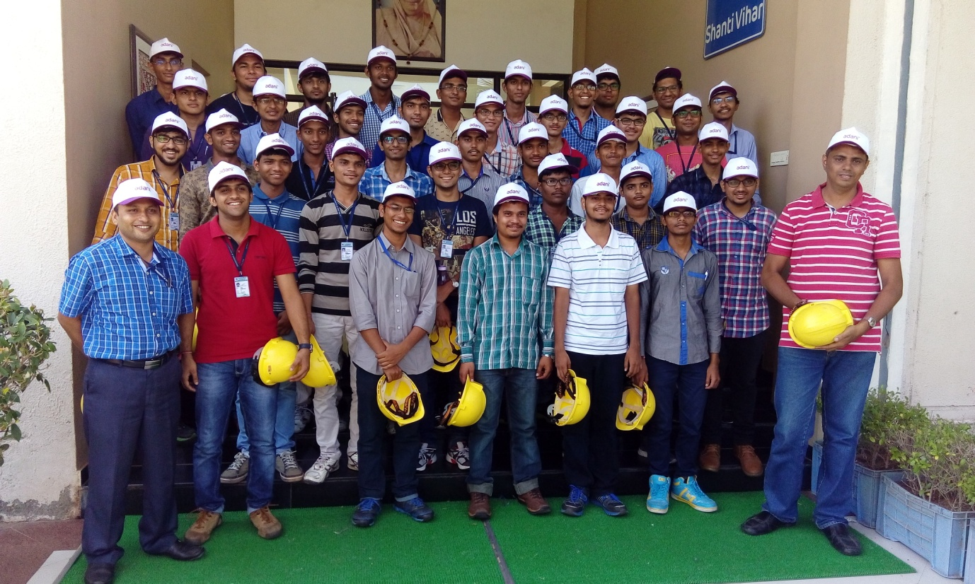Group-photos of Students and Faculties at Adani Mundra Port.

Prof. H.A.Shukla & Prof. H.P.Patel
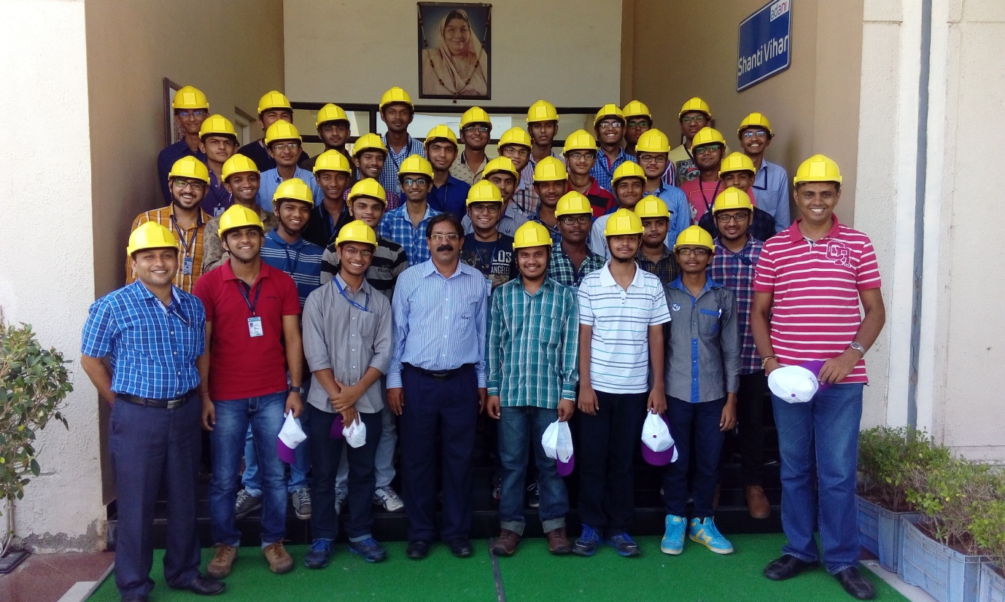

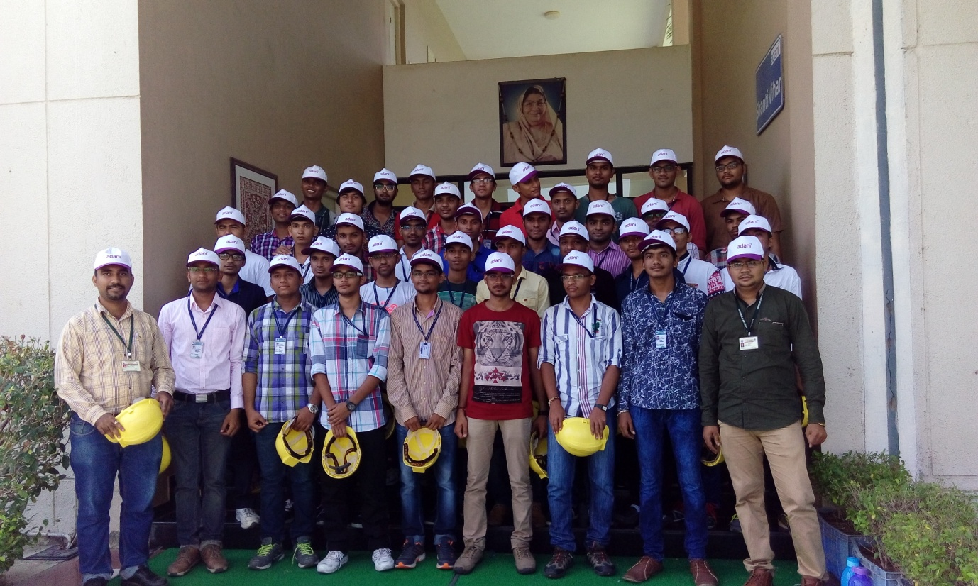Prof. J.G.Parmar & Prof. R.J.Chobe
