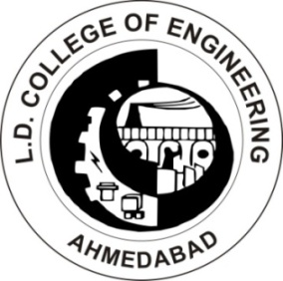
L D College of Engineering, Ahmedabad
Republic Day Celebration 2018
Nomination Form for students

Personal Details – (Please fill in BLOCK letters)

Name of the student :- ………………………………………………………………………

Semester :-………… Branch :-…………………………….

Enrollment No :-……………………………..

Mobile No. :-………..................................

E-mail ID :-…………………........................................................................

Details of Event

Name of Event :-…………………………………..

Date of Event :- ……………………………………..

Achievement :-………………………………………. …………………………………...

…………………………………...………………………………………………………………….

………………………………………………………………………………………………………

………………………………………………………………………………………………………

………………………………………………………………………………………………………

………………………………………………………………………………………………………

………………………………………………………………………………………………………

Additional Details :-………………………………….

Encl .:-………………………………………………..

(Note:- Please attach photocopy of certificates of achievements. Attach additional sheet if required for achievement.)

