REPORT ON INDUSTRIAL VISIT AT KOTARPUR WATER WORKS, AHMEDABAD under the aegis of IEI students chapter, EED, LDCE

September 27,2023
Ahmedabad

Introduction:
The visit was initiated by the Department of Electrical Engineering. It was a One-Day industrial visit to Kotarpur water works, Ahmedabad. The aim is to get an Industrial exposure for future endeavour and awareness regarding water to the students. On September 27,2023 visited along with 40 students and 2 faculty members Prof. H.N.Ranal and Dr.K.A.Bhatt .

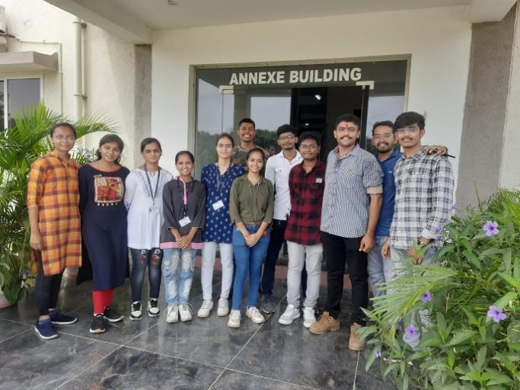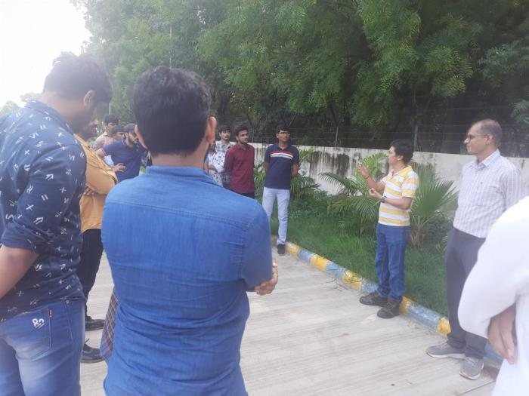
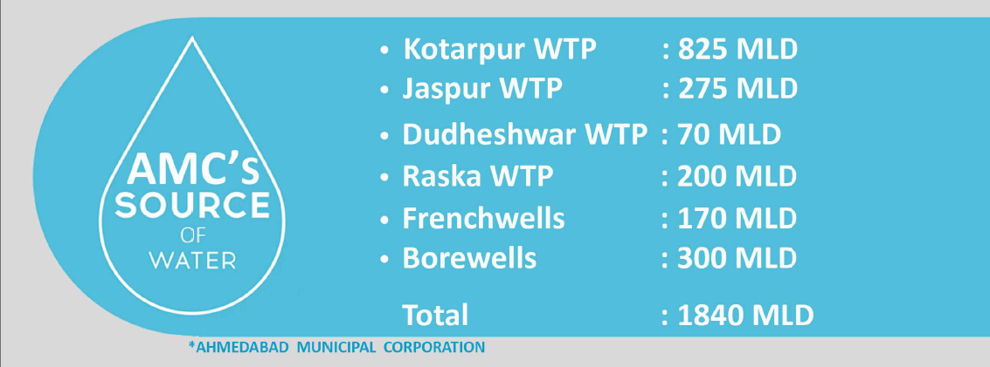

Kotarpur plant treats 650 MLD water and max. 750 MLD water accumulated from Narmada by gravity flow and from Sabarmati by pumping. It provides 80% of water demand of 1100 MLD consumption of Ahmedabad city and it is the largest water treatment plant in Asia till now. 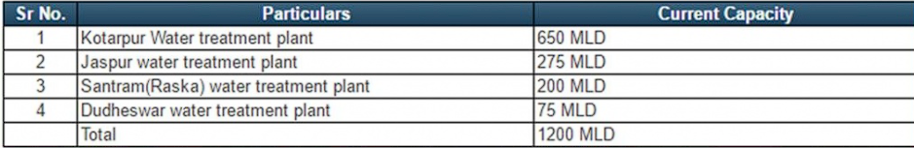

General Information about Kotarpur WTP:
- 650 MLD water treatment plant was constructed from 1983 to 1987, but surface water source from Dharoi was not adequate, it was not commissioned.
- The Narmada canal alignment was planned by Government of Gujarat & Kotarpur water works and escape in the river Sabarmati was constructed and commissioned. So that Narmada canal water was available in the river to pick up this water, AMC has planned Intake well work in two phases.
- Dudheswar Water Works & seven French wells were come in operation from August 2002. Thereafter to develop an assured source, work of gravity mains was conceptualized.
- Gravity line of 2500 mm dia from Narmada main canal to Kotarpur water works is laid in December 2006 & commissioned from January 2007. By this gravity line AMC getting 330 MLD water to Kotarpur water works.
Capacity of Water treatment plant are as follows:
- 650 MLD (Manually operated)
- 200 MLD (PLC-SCADA operated)
- 300 MLD (Fully automated)
In WTP we have visited fully automated 300 MLD plant
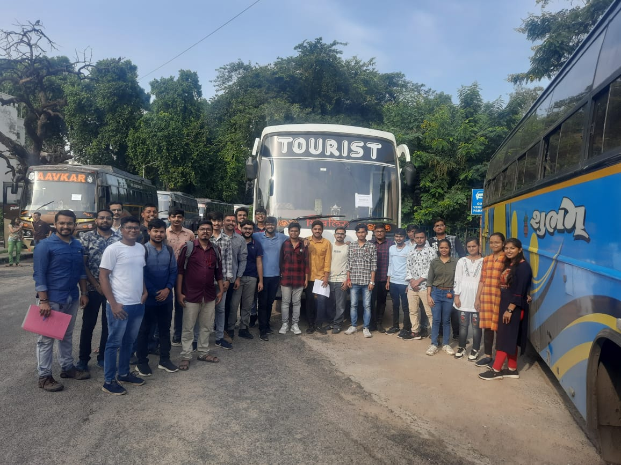

Types of Impurities found in water
1. Floating type: Removed using screening process.
2. Suspended solids: Removed using chemical process
Narmada River and Sabarmati River are the two resources of Raw Water for Kotarpur WTP. There are 48 nos. of Clear Water Tank at Kotarpur WTP. 900 kg cylinder of chlorine is used for chlorination and 2 cylinders per day (24 hrs) are used every day. There are 10 Pumps at the plant. Each pump is having capacity of 4.1 million per hour. After Post Chlorination process, water is distributed to Ahmedabad from the pump station.
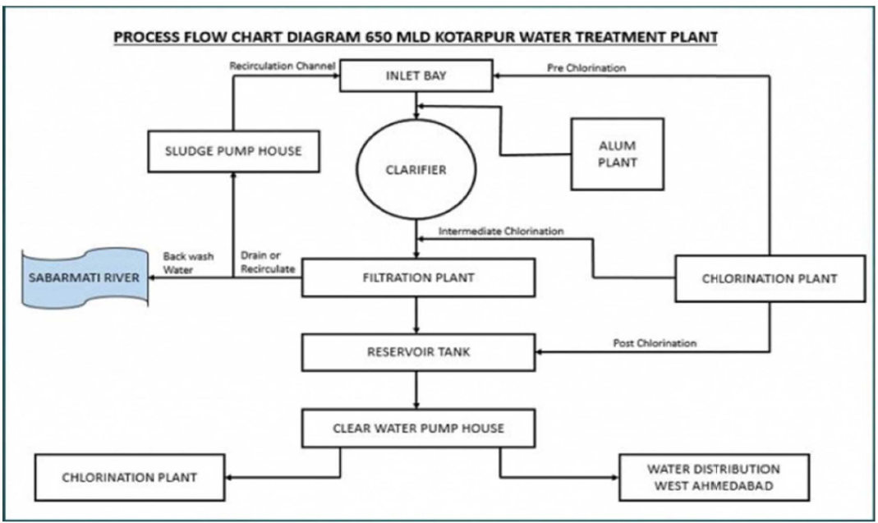
Stages of water works plant: Raw Water Sources, Clarification of water and Sedimentation of impurities, Sludge Plant, where residuals of Clarification plant are treated, Filtration Plant, Chlorination Plant and Clear Water Tank and Pump Station. It further classified into some stages: -
- Source of water: -
      - Narmada main canal
      - Raw water Pump house
Raw Water Quality
Raw Water Turbidity | 25 to 1000 NTU
Raw Water pH Value | 7.80 to 8.60

Treated Water Quality:
Turbidity | Less than 1 NTU
pH Value | 7.0 to 8.0
Residual Chlorine | 0.5 to 1.0 ppm

GUARANTIES:
Alum Consumption | Jar test 20%
Sludge bleed from clarifiers | 6%
Up Wash consumption | 3% Max.

TOP WATER LEVEL IN VARIOUS STRUCTURES
Intel Bay | 63.00 m
Flash Mixer Chamber | 62.00 m
Clarifiers | 61.00 m
Filter Beds | 60.55 m
Back Wash Water | 58..60 m

- Intake (Pump house): -
Vertical Turbine Pump: 8 Nos
Capacity: 2500 M³/hr
Head: 27.51M
Motor: 250KW,415±10%V

- Inlet Bay: -
Top Water Level: 63.00 M
The Water is collected from different sources.
Narmada water from Main Canal

- Distribution Chamber/Flash Mixer: -
Top Water Level: 62.00 M
S.S Agitator Provided for Proper Mixing of Chemical

- Chemical House: -
Alum Solution Tank: 6 Nos.
Effective Capacity:41.6 M³
Alum Dosing Pump:6 Nos. (4W+2S)
- Clariflocculators: -
Total:06 Nos.
Dia. Of Clarifiers:49.00 M
Dia. Of Flocculator Zone:20.00 M
Max. Flow Rate:36.0 M³/Day/M²
Detention Period: I) Flocculator Zone-30 Minutes
II) Clarifier Zone-2.30 Hours
Water Depth:3.5 M

- Back Wash Pump & Blower Area:
Backwash Rate:2020M³/hr (2W+1S)
Air Wash Rate:3100 M³/hr (2W+1S)
Wash Water Flow:10 Minutes
Air Sourcing:05 Minutes
- Filter House:
Type: Declining Rate Filter
Beds: Total 32 Nos. having area of 83.33 M³ each
Filter Under drain System: 80 mm Dia
Filtration Rate:500 M³/hr
Filter Media: Gravel -225 mm, Sand-900 mm

- Clear Water Pump House:
Type: HSCF Pump
Capacity:4167 M³/hr
Head:12.5 M
Motor Drive:200KW,415±10%V
Transformer: 2 Nos. of 1000KVA
Total Pumps:3 Nos. (2W+1S)

- CHLORINE TONNER CHLORINE PANEL
Gross Weight- 1500Kg Total Chlorinator-6 Nos.
Nett Weight - 900Kg Capacity- Pre25 Kg/hr (3 Nos.)
Tare Weight – 600Kg Capacity- Post15 Kg/hr (3 Nos.)

VACUUM INJECTOR
Total Vacuum Injector – 6 Nos.

- CLEAR WATER RESERVOIRS & CHLORINE CONTACTS TANK
Size of Tank: 92X58 M
Depth of Tank:4.50 M
Capacity of Tank:24000 M³

- SERVICE WATER TANK
Capacity of Tank :18M³
Service water Pumps:2 (1W+1S)
Capacity of Pump:20 M³/hr

- Administrative Building: The complete monitoring and operations of treatment plant is controlled from this building and it has a complete facility for testing of water.

Several tests performed in Laboratory:

- Jar meter Test
- pH meter Test
- Turbidity meter Test
- TDS meter Test
- Coliform Test
Summary
In this water treatment plant, the source of water is Narmada and reaches to plant through gravity. Alum dosing and initial chlorination is being done. Various parameters of water like pH, Turbidity, Flow are measured through various sensors & actuators and that data is conveyed to control room. To remove turbidity of water Clariflocculator is used. With the help of stirrer and VFD controlled scavenger the mixer and sludge is collected from the bottom of Clariflocculator. The intermediate chlorination is performed after settling down of sludge. The filtration process was done, when differential pressure across filter goes beyond predetermined value filter cleaning was performed in which air purifying & high-pressure water is used. To control electrical auxiliary APFC panel is used. The whole process is PLC and SCADA based operated system. Battery bank was used for power backup up-to 8 hours for DCS panel. In Chemical laboratory various test was performed on water. Entire plant visit was nicely explained by Sh. Nishant bhai, Ju. Engineer, 300 MLD water plant, Kotarpur water works.
At last, vote of thanks is given by Dr.K.A.Bhatt and few students named Pratham, Akshar, and Abhay.

