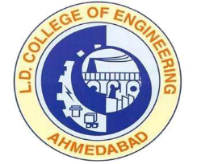 | L.D.College of Engineering,Ahmedabad-380015  एल.डी.कोलेज ऑफ़ इंजीनियरिंग, अहमदाबाद–३८००१५  લા.દ.ઈજનેરી મહાવિદ્યાલય,અમદાવાદ-૩૮૦૦૧૫  Phone:079-26306752 (Office), 26303190  Email: ldce-abad-dte@gujarat.gov.in Website: www.ldce.ac.in
L.D.C.E./STS/ / Date: - / /20

No Objection Certificate

Mr. ………………………………………………………… is studying in this institute in ………………... Engineering
in semester…….. His Enrollment No. is ………………………………..
He has applied for cancellation of his Enrollment from Gujarat Technological University. This institute has no objection in his cancellation of Enrollment.

PRINCIPAL
L.D.COLLEGE OF ENGINEERING
AHMEDABAD

