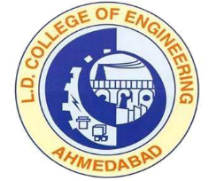 | L.D.College of Engineering,Ahmedabad-380015  एल.डी.कोलेज ऑफ़ इंजीनियरिंग, अहमदाबाद – ३८००१५  લા.દ.ઈજનેરી મહાવિદ્યાલય,અમદાવાદ-૩૮૦૦૧૫  Phone:079-26306752 (Office), 26303190  Email: ldce-abad-dte@gujarat.gov.inWebsite: www.ldce.ac.in
L.D.C.E./STS/ / Date: …. /…./………
English Proficiency Certificate
Mr. …………………………………………………………………………………… was a bonafied student of L.D. College of Engineering, Ahmedabad (Affiliated to Gujarat Technological University) for the course of B.E. (…………………………………….), his academic studies in our institute were from ……………………to …………………. During these years of studies, the medium of instruction and examinations at Gujarat Technological University was English.

Principal
L.D. College of Engineering
Ahmedabad

